Use Case name: Assign Lecturer to Module

Participating Actor: HOD

Entry conditions:

1 HOD wishes to assign lecturer to module

2. Hod invokes the Assign Lecturer to Module function.

Flow of Events.

1. The systems displays the Assign Lecturer to Module screen with a list of lecturers (names, names of modules already assigned) and requests the HOD to select one and it also displays a list of modules (name, num of hours already assigned, num hours required) and requests the HOD to select one and requests him and requests the number of hours to assign and then to click assign
2. The HOD selects a lecturer and a module and clicks and enters the num of hours and clicks assign
3. The system diaplays a confirmation showing the lecturer and the assigned module and click finish

Special condition

1. Display only lecturers and modules in the same department as the HEAD
2. Display unassigned modules first in list and then followed by recently assigned modules
3. Search later

Use Case diagram

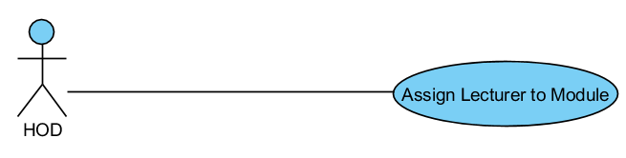

Class Diagram

(Before creation of Sequence diag)

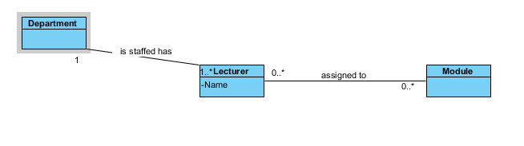

Sequence diagram

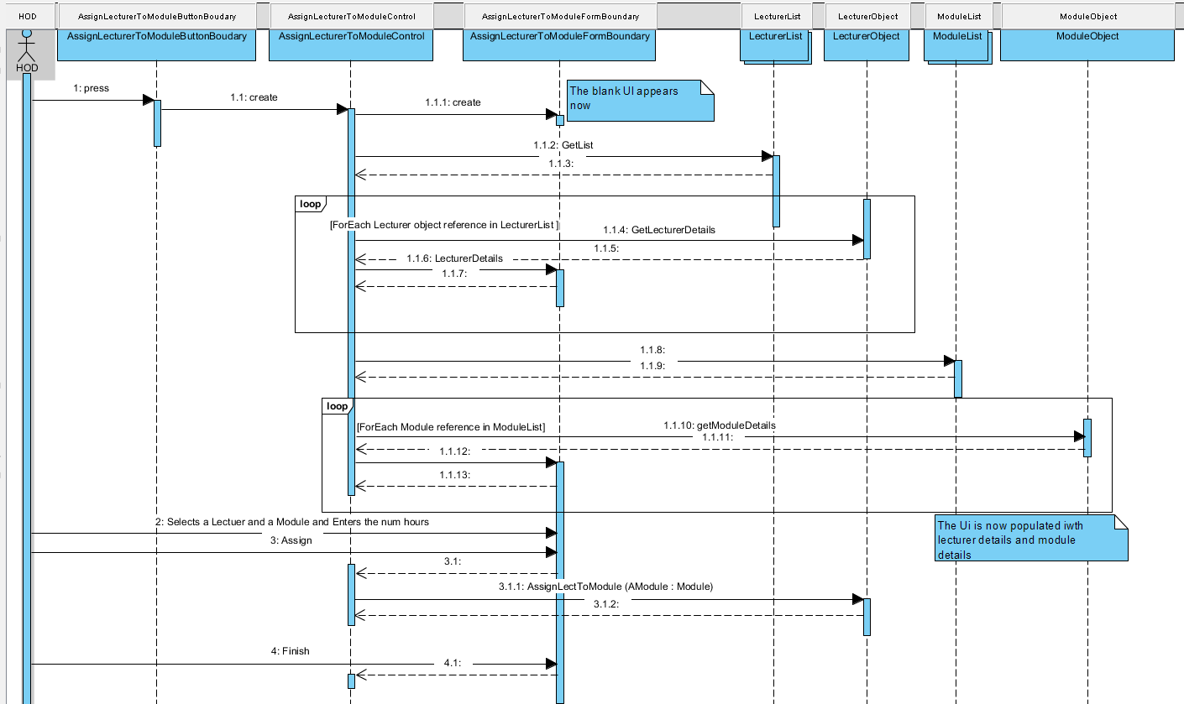

Class diagram

Updated during creation of sequence diagram

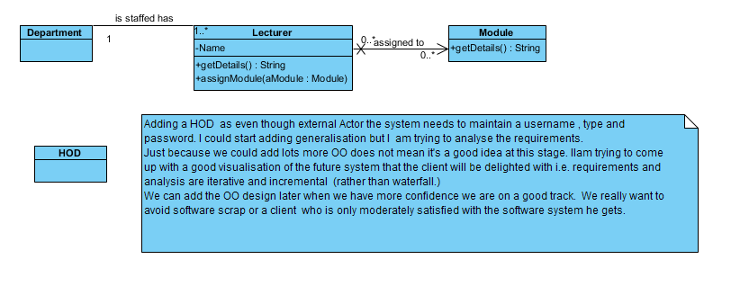

There are lots of questions we need to clarify with the client on the above and we need to figure out how to make the assignment more efficient as HODs don’t want to have to manually assign all modules. We need to figure out the DeAssign module. Management of assignment of modules is a fundamental part of a college business, it’s not a peripheral activity it’s core. As a result we would want to focus attention on it. An effective team wold relentlessly pursue the issues so that they specify a really good visualisation of the future system and they would then follow through confidently with the design, implementation, test.